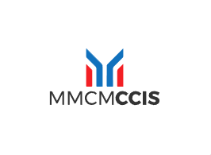

1. Proximity

The letters "MMCM" and "CCIS" are positioned close together, indicating they are part of a cohesive unit. The bars above the letters are also grouped closely, suggesting they belong together and relate to the text below.

2. Similarity

The red and blue bars are similar in shape and size, creating a sense of unity and suggesting they belong together. The consistent color scheme (red, blue, black) across the logo ties all elements together visually.

3. Continuity

The design of the bars above "MMCM" and "CCIS" creates a continuous flow, guiding the viewer’s eyes from the sides at the top down to MMCM and CCIS. The symmetry and alignment of the bars help create a smooth visual path.

4. Closure

The design of the bars suggests the letter "M" even though they are not completely closed. The brain fills in the gaps, interpreting the shapes as meaningful letters related to the text below.

**Relevance of the design**

The principles of proximity and similarity ensure that all elements of the logo are seen as part of a single entity, representing CCIS as a part of MMCM. Continuity and closure create a visually appealing and easily recognizable design. The viewer’s brain effortlessly completes the shapes, making the logo memorable.